Geometry: Unit 5, Lesson 3
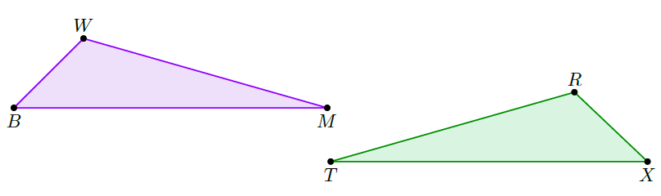
- $∆WBM$ and $∆RXT$ are shown where $∠WBM≅∠RXT$ and $∆BMW ≅∠XTR$. What other information is necessary to show that $∆WBM ≅∠RXT$ using AAS Congruence?

$\overline{WM}≅\overline{RT}$ or $\overline{WB}≅\overline{RX}$

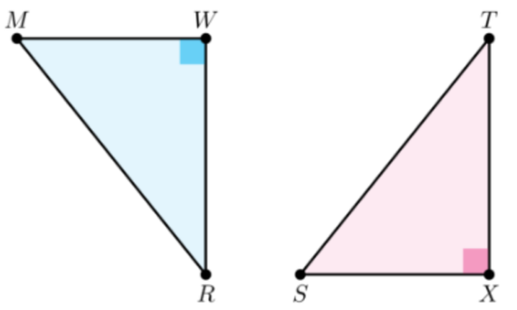
- Triangles $MWR$ and $SXT$ are shown where $\overline{WR}≅\overline{XT}$, $\overline{WR}⊥\overline{MW}$, and $\overline{TX}⊥\overline{SX}$. Given that $∠RMW≅∠TSX$, what can prove that the two triangles are congruent?

AAS Congruence

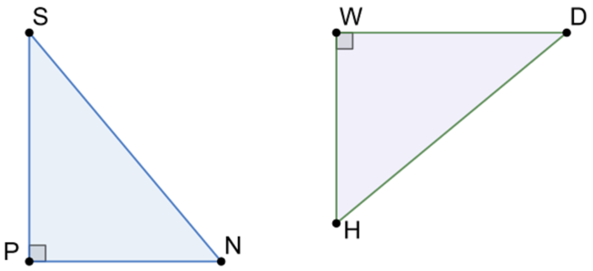
- Right triangle $SPN$ and right triangle $DWH$ are shown. What other information is necessary to show that $SPN≅DWH$ using the Hypotenuse-Leg Congruence Theorem?

$\overline{SN}≅\overline{DH}$ and $\overline{PN}≅\overline{WH}$

